Project Mentality

Carson Perry

CST-451 Capstone Project Requirements Document

Grand Canyon University

Instructor: Professor Michael Landreth

Revision: 4

Date: 2/24/21

**ABSTRACT**

Summarize the entire project in 2-3 paragraphs, about 15-20 lines. The abstract should be enough for one to get an idea of what this project is about, what was the task, and what you accomplished. Briefly provide the broader context. Write this section only after the entire project is complete.

|  |
| --- |
| History and Signoff Sheet |

**Change Record**

|  |  |  |
| --- | --- | --- |
| **Date** | **Author** | **Revision Notes** |
| 3/4/21 | Carson | Added some use cases |
| 3/5/21 | Carson | Added some use cases, and began work on the 3 diagrams required |
| 3/6/21 | Carson | Added some use cases and finished the 3 diagrams |

|  |
| --- |
| **Overall Instructor Feedback/Comments** |

|  |
| --- |
| **Overall Instructor Feedback/Comments** |

**Integrated Instructor Feedback into Project Documentation**

Yes  No

**TABLE OF CONTENTS**

Functional Requirements 4

Non-Functional Requirements 5

Technical Requirements 6

Logical System Design 7

User Interface Design 8

Reports Design 9

Functional Requirements

**Use Cases**

|  |  |  |
| --- | --- | --- |
| **Use Case or User Story** | **Approval Date** | **Justification** |
| **As a user, I would like to be able to choose which level to play.** | **3/4/21** | **Having users have to go through other levels, even if they only want to play a level associated with an illness of someone close to them, would be really annoying and there’s no reason for that.** |
| **As a user, I would like to be able to save my progress in a level.** | **3/4/21** | **The levels aren’t intended to be too long, however, it would be annoying to lose your progress if something comes up, or a bug occurs.** |
| **As a user, I would like, after completing a level, to be taken back to the main menu to choose another game, rather than go to another level.** | **3/4/21** | **Similar reasoning as the first User Story. Choice in what levels to play, aids in the enjoyability as well as accessibility of the game.** |
| **As a user, I would like to experience the levels alone.** | **3/5/21** | **Single player gameplay enhances immersion and has less distractions when trying to convey a message.** |
| **As a user, I would like the controls for movement to be the WASD format.** | **3/5/21** | **Most games use the WASD keys for movement. All the first-person games I’ve played use that format, and only Japanese 2D games have used arrow keys for the movement. This allows for more immersion with less distraction of using an unpopular movement format.** |

Non-Functional Requirements

**Use Cases**

|  |  |  |
| --- | --- | --- |
| **Use Case or User Story** | **Approval Date** | **Justification** |
| **As a developer, I would like to be able to add more levels in the future.** | **3/4/21** | **This way, I can add more illnesses to help even more people as the game grows.** |
| **As a user, I would like to be able to send crash reports automatically to help fix issues.** | **3/4/21** | **I would like to fix bugs, but not hinder the users more than I already have with the failed code with a crash causing bug passing tests.** |
| **As a user, I would like for the information given in these levels to be accurate.** | **3/5/21** | **The only way this game can be helpful to people is if the information about the illnesses being explained are accurate.** |
| **As a user, I would like there to be some nice, calm music.** | **3/5/21** | **Calm music would indeed sound nice, as well as help fill empty air in menus and possibly some points of the levels as well.** |

Technical Requirements

**Use Cases**

|  |  |  |
| --- | --- | --- |
| **Technology or Tool** | **Approval Date** | **Justification** |
| **Unity Game Engine** | **3/4/21** | **I have experience in Unity, and have access to lots of learning material for this game engine. It’s a fantastic and free to use game engine that many professional studios still use to make video games today.** |
| **Blender** | **3/4/21** | **Blender has good animation and skeleton tools for 3D models. This will aid in creating the setting and characters and animations in the game.** |
| **FL Studio** | **3/4/21** | **I already own the full version of it, and it’s a great Digital Audio Workbench. This is what I will use to manipulate sound effects and possibly voice overs for the game.** |
| **Cel Shading** | **3/5/21** | **This would add a really nice and pleasant stylized look to the game.** |
| **Visual Studio** | **3/6/21** | **This is, by far, my favorite IDE and the most well made in my experience.** |
| **XNA Framework** | **3/6/21** | **This may or may not be implemented. However, if after learning more about this framework, it may reduce my work load.** |

Logical System Design

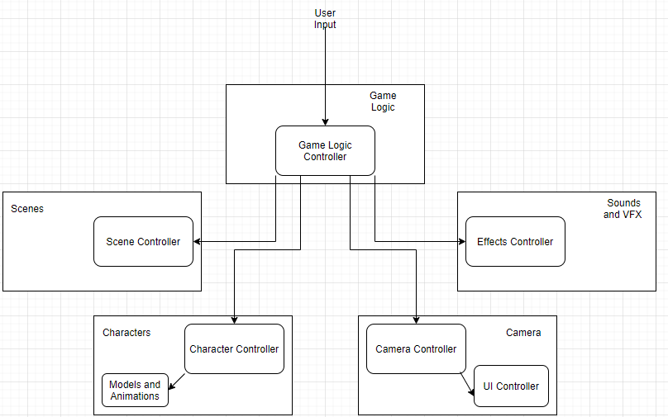

User Interface Design

Main Menu:

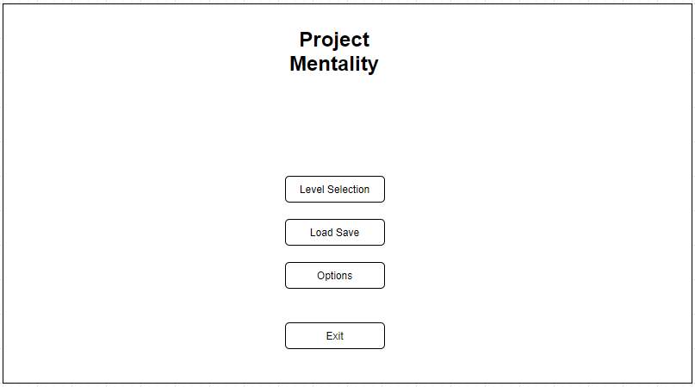

OCD Level UI (Empty space is the game, text is managed by a UI controller):

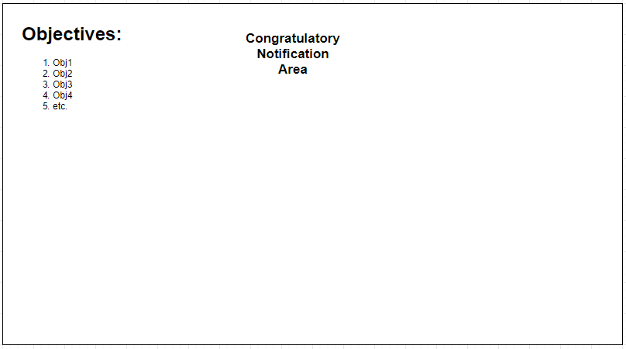

Reports Design

The game will be able to send a report to an email set up specifically for this game, that includes state information of the game, where the game crashed, and what method was called. This will be done using an interceptor class to log and ensure the game knows where it is and can send that information if an error or crash occurs.